**DIGITAL MARKETING ASSIGNMENT**

**WEBSITE ABSTRACT**

**Sow & Grow (Indoor Plants)**

 **NAME** : Khathijathul Kubra M

**RRN** : 240282601038

**DEPARTMENT** : Computer Application

**CLASS** : MCA

**YEAR** : 1st year

**ABSTRACT:**

***Sow&Grow: Your Source for Premium Seeds and Indoor Plants***

Sow&Grow is an online platform dedicated to providing high-quality seeds and indoor plants for gardening enthusiasts and homeowners looking to enhance their living spaces. With a focus on convenience and sustainability, our website offers a wide selection of plants ranging from easy-to-care-for houseplants to unique, rare species. In addition, we provide premium seeds for individuals interested in cultivating their own indoor gardens.

**Website Features:**

* **Extensive Plant Catalogue**: Browse a variety of indoor plants, including popular species like air purifying, low maintenance and flowering plants, as well as herbs and medicinal varieties.
* **Seed Shop**: A diverse collection of seeds for indoor gardening, including vegetables, herbs, flowers, and ornamental plants, all carefully curated for optimal growth in small, indoor spaces
* **Plant Care Guides**: Detailed information on plant care, watering schedules, and environmental needs to help customers keep their plants healthy.
* **Easy Online Ordering**: A simple, secure, and user-friendly checkout process for a smooth shopping experience.

**Programming Languages Used:**

* **HTML**: For structuring the content and layout of the website.
* **CSS**: For styling and creating a visually appealing design.
* **JavaScript**: For adding interactivity and dynamic content to enhance user experience.
* **LocalStorage**: To store user preferences and data locally without the need for a backend, enabling a more personalized experience.

**Tools Used:**

* **GitHub**: For version control and hosting the website using GitHub Pages.
* **ChatGPT**: Used to assist with code generation, troubleshooting, and content creation.
* **Canva**: For designing and editing images and visual elements to enhance the overall website design.

**HOME PAGE**

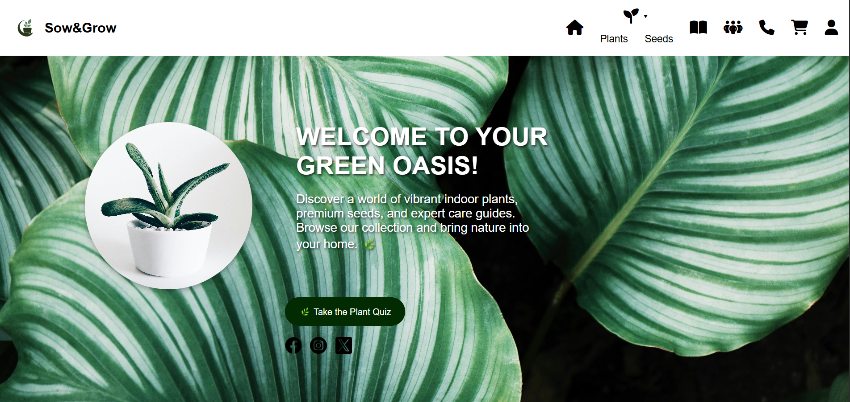

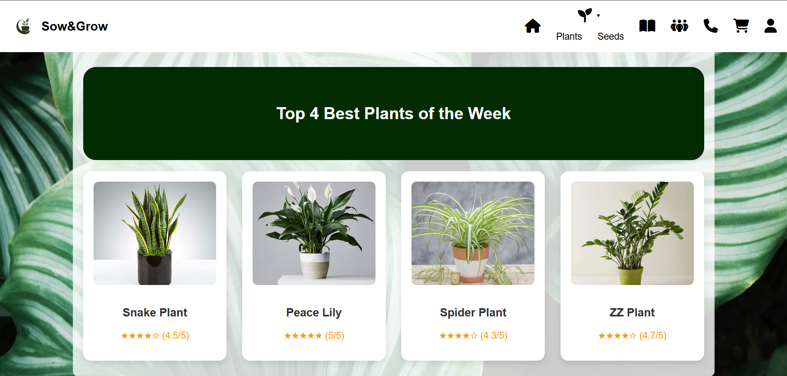

**PRODUCT CATEGORY PAGE:**

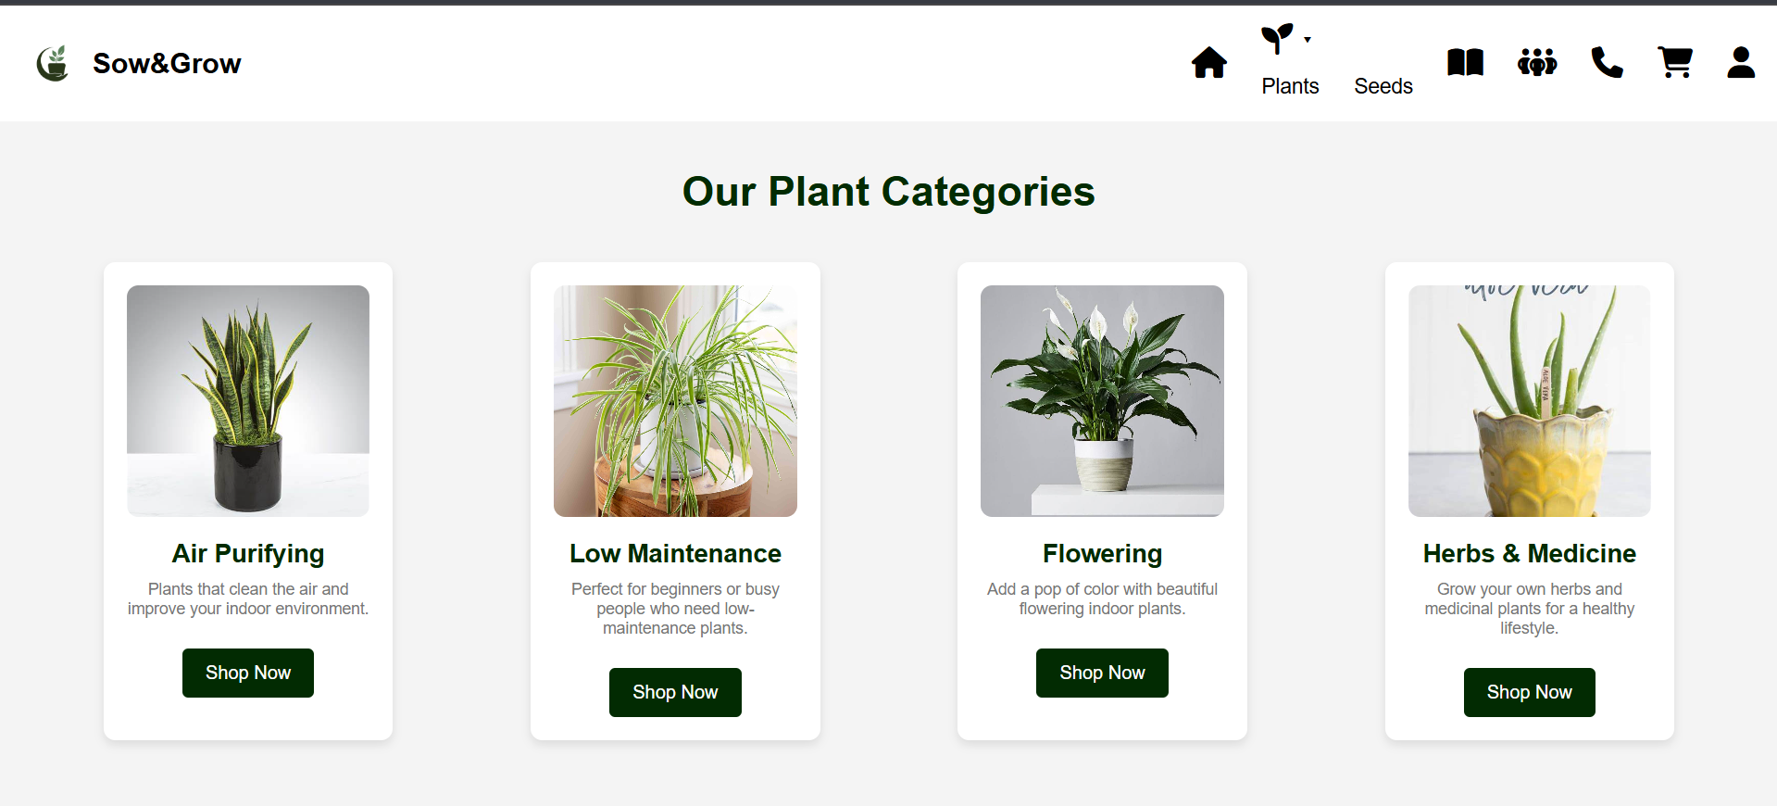

**PRODUCTS PAGE:**

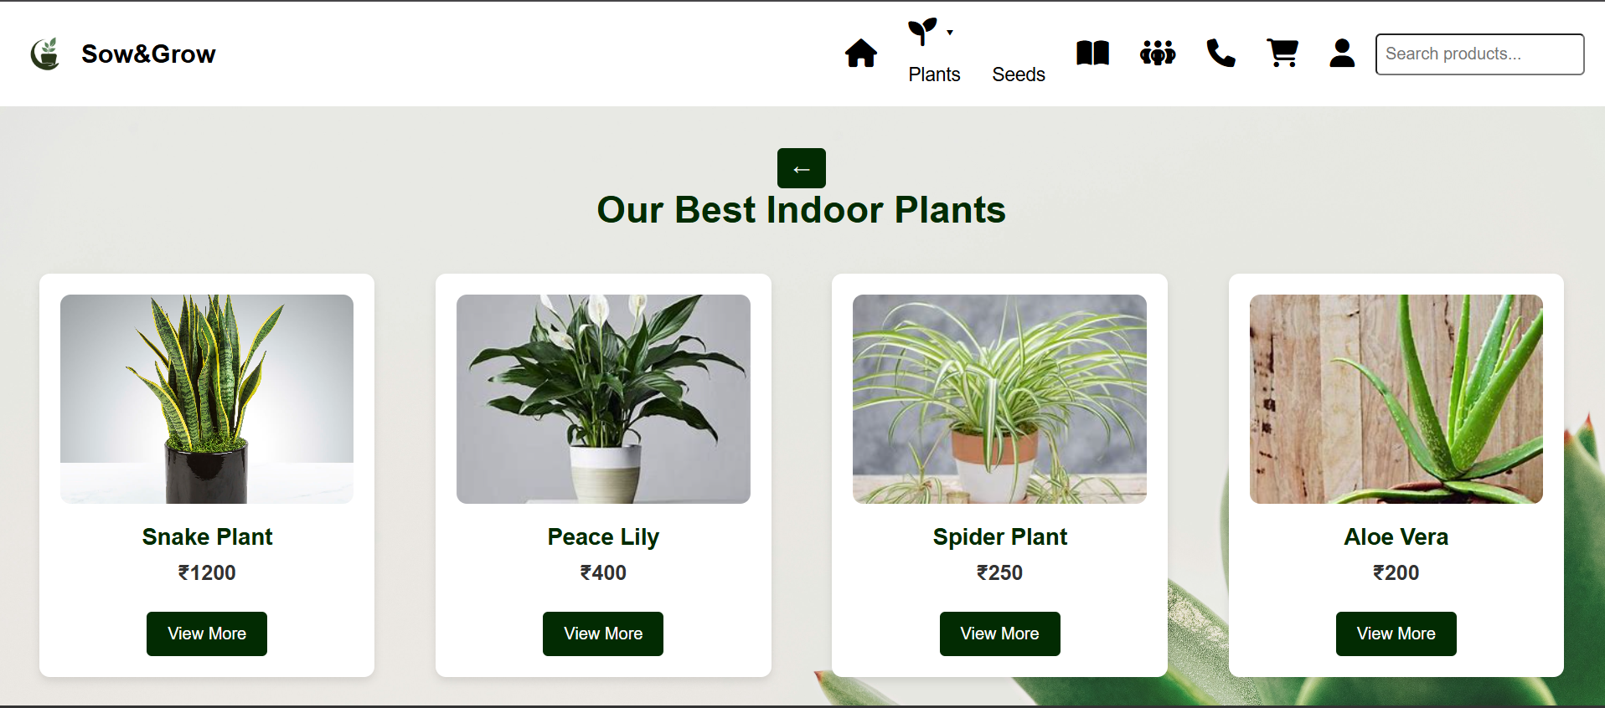

**PRODUCTS DETAILS:**

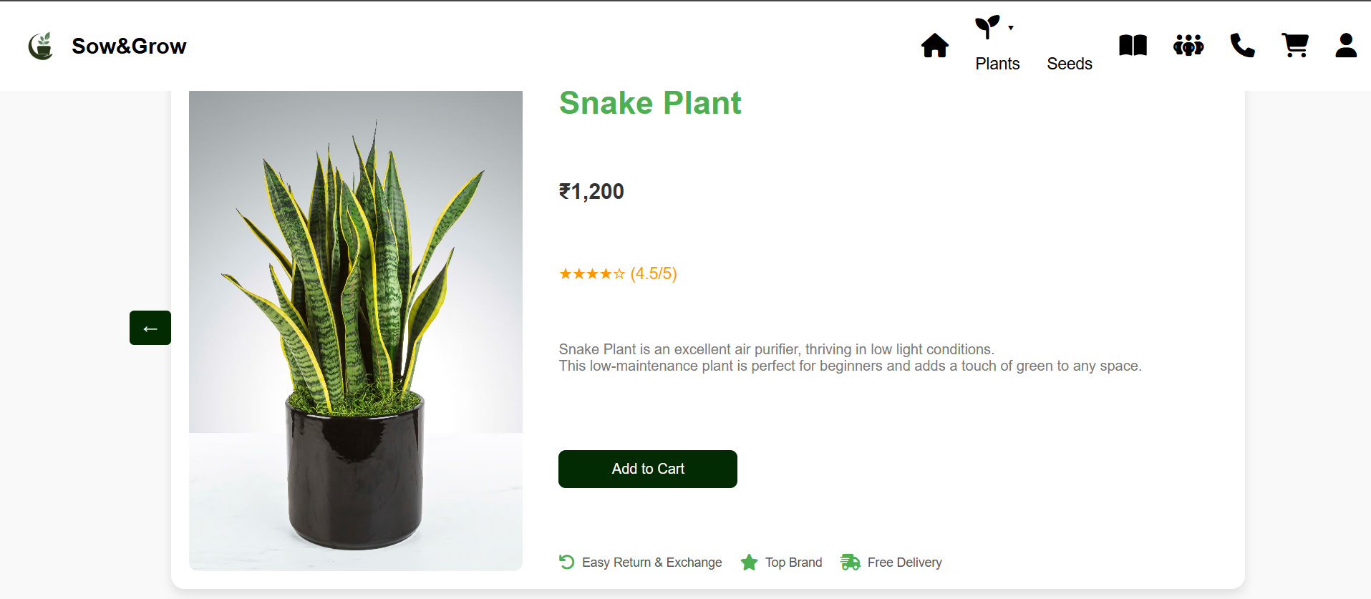

**ABOUT US PAGE:**

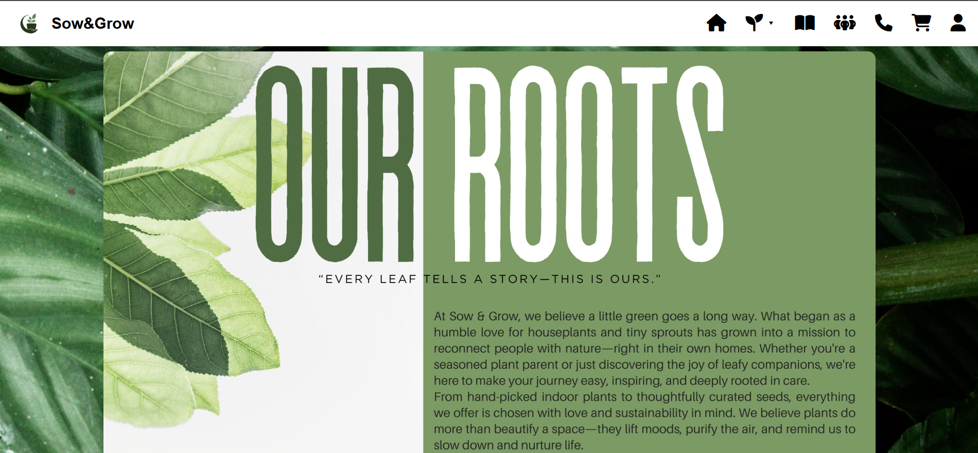

**CONTACT US PAGE:**

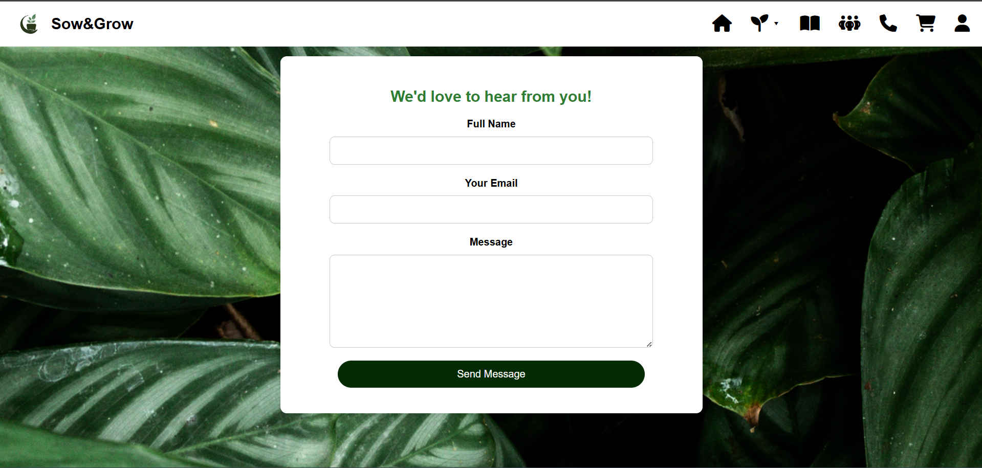

**CART PAGE:**

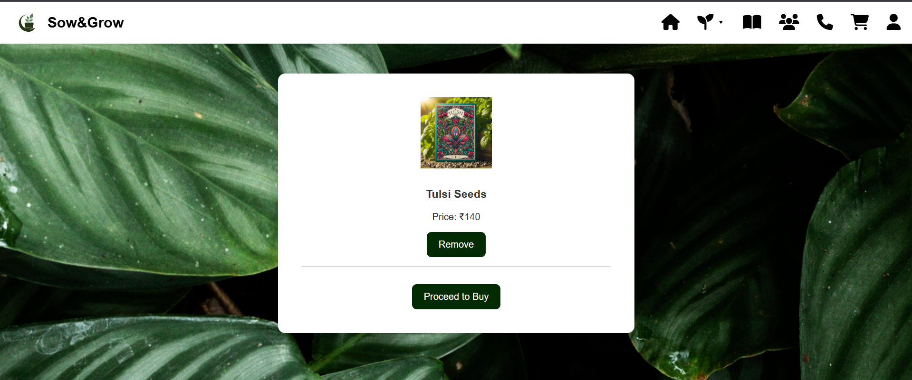

**CHECKOUT PAGE:**

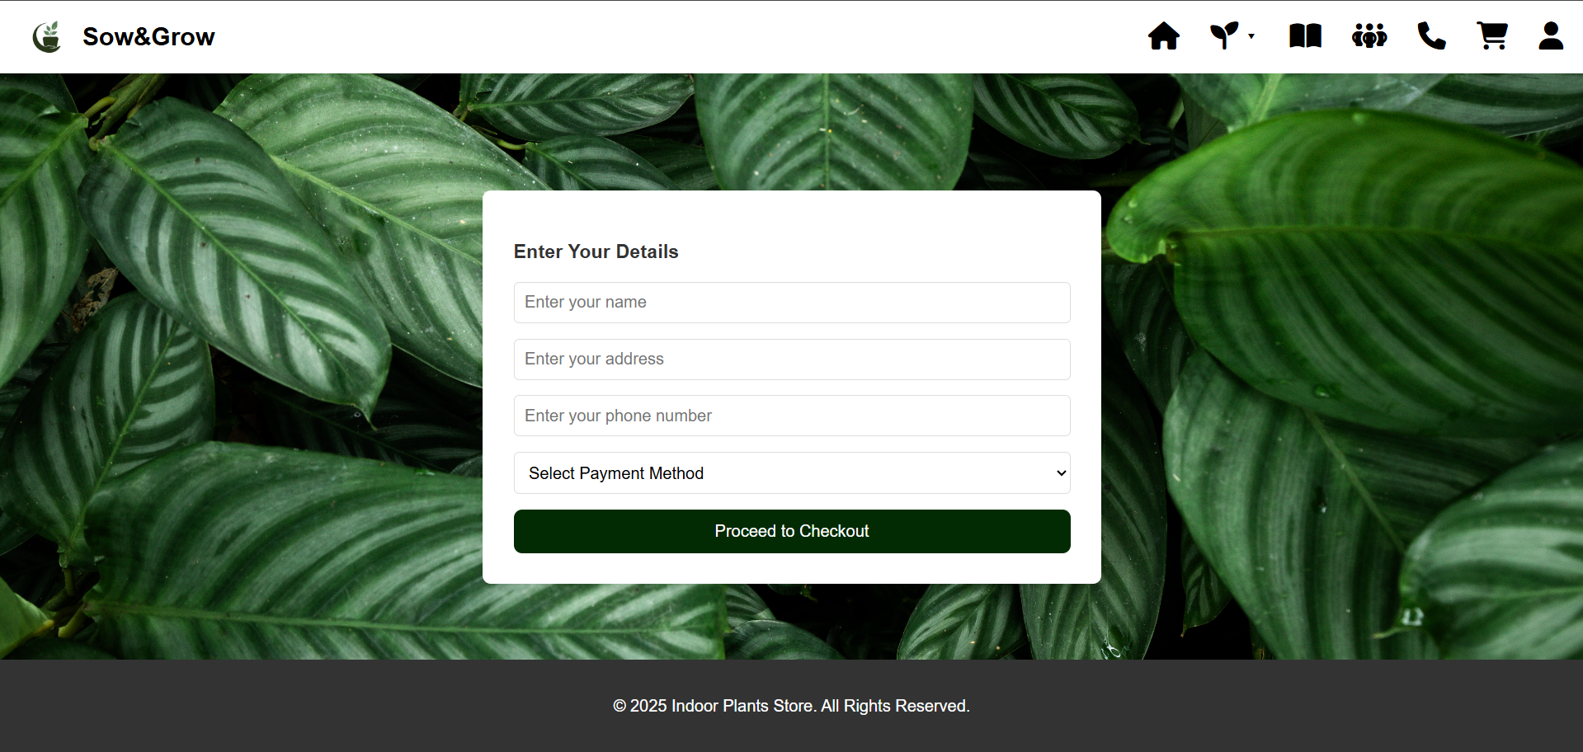

**LOGIN PAGE:**

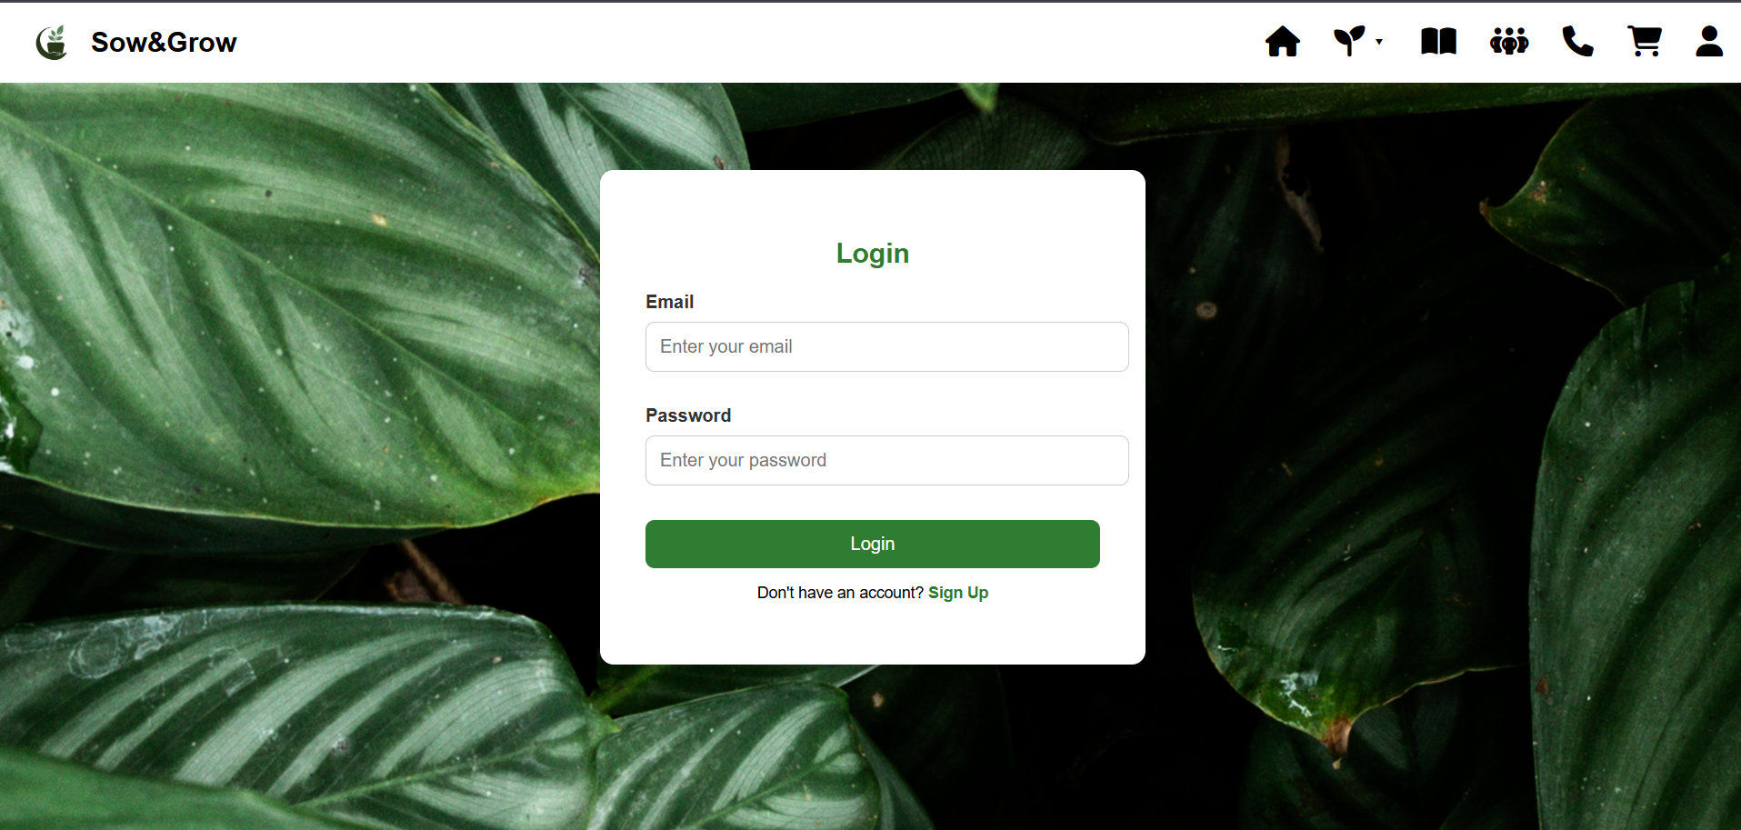

**FAQ PAGE:**

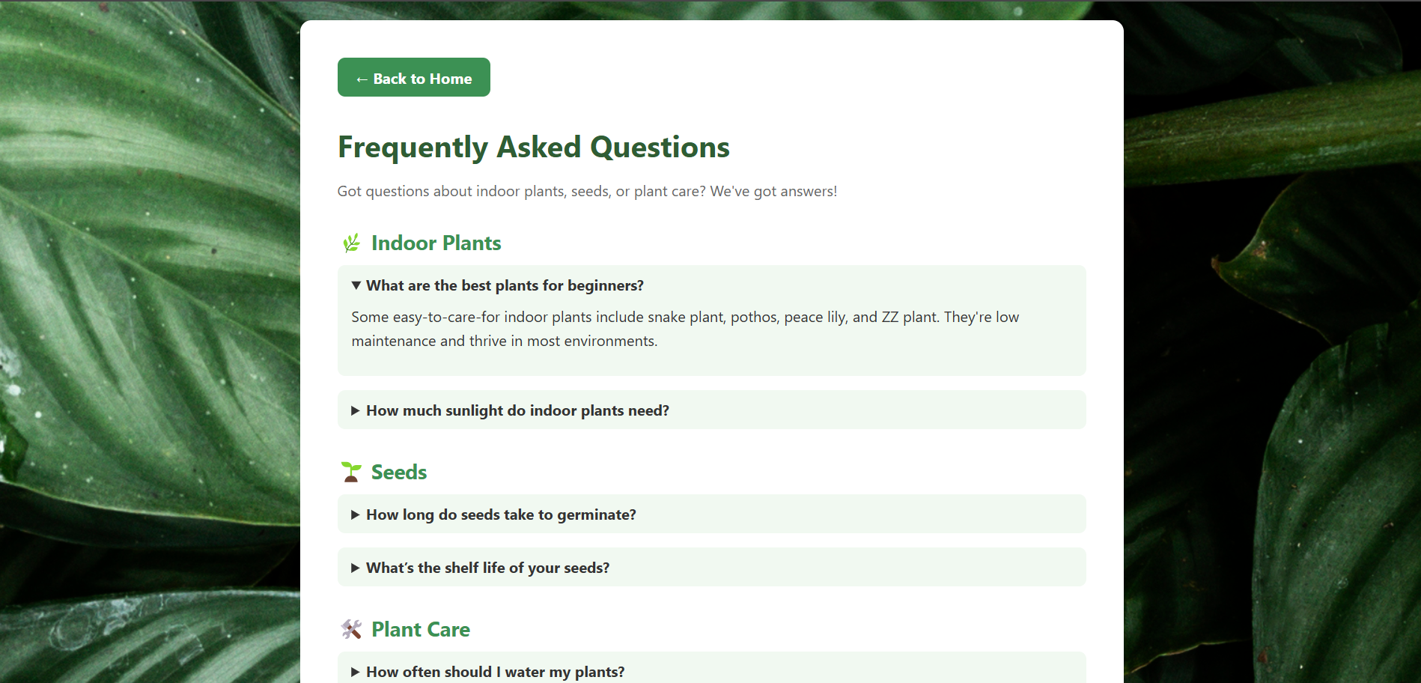

**CODE:**

**HOME PAGE:**

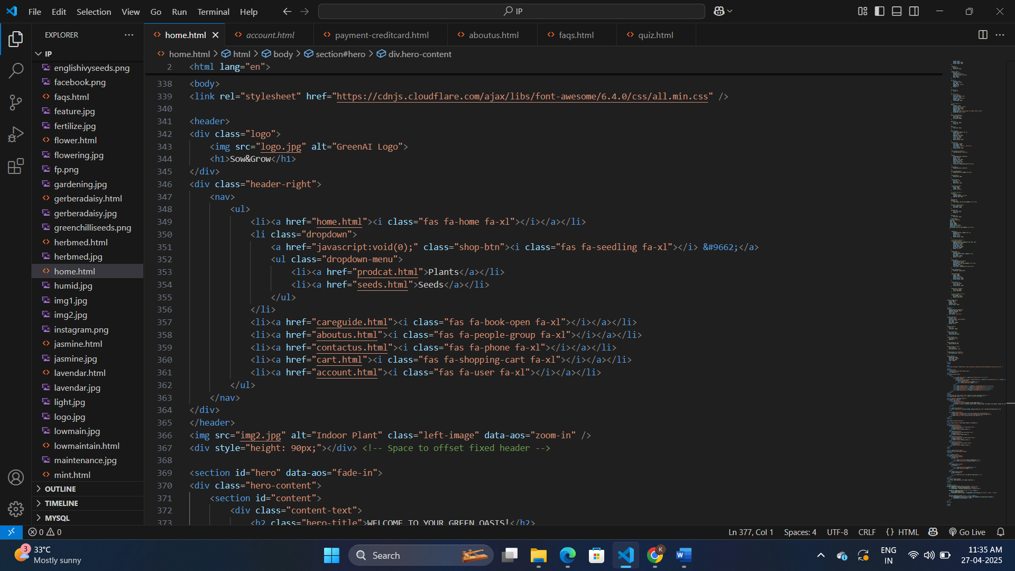

**PAYMENT PAGE:**

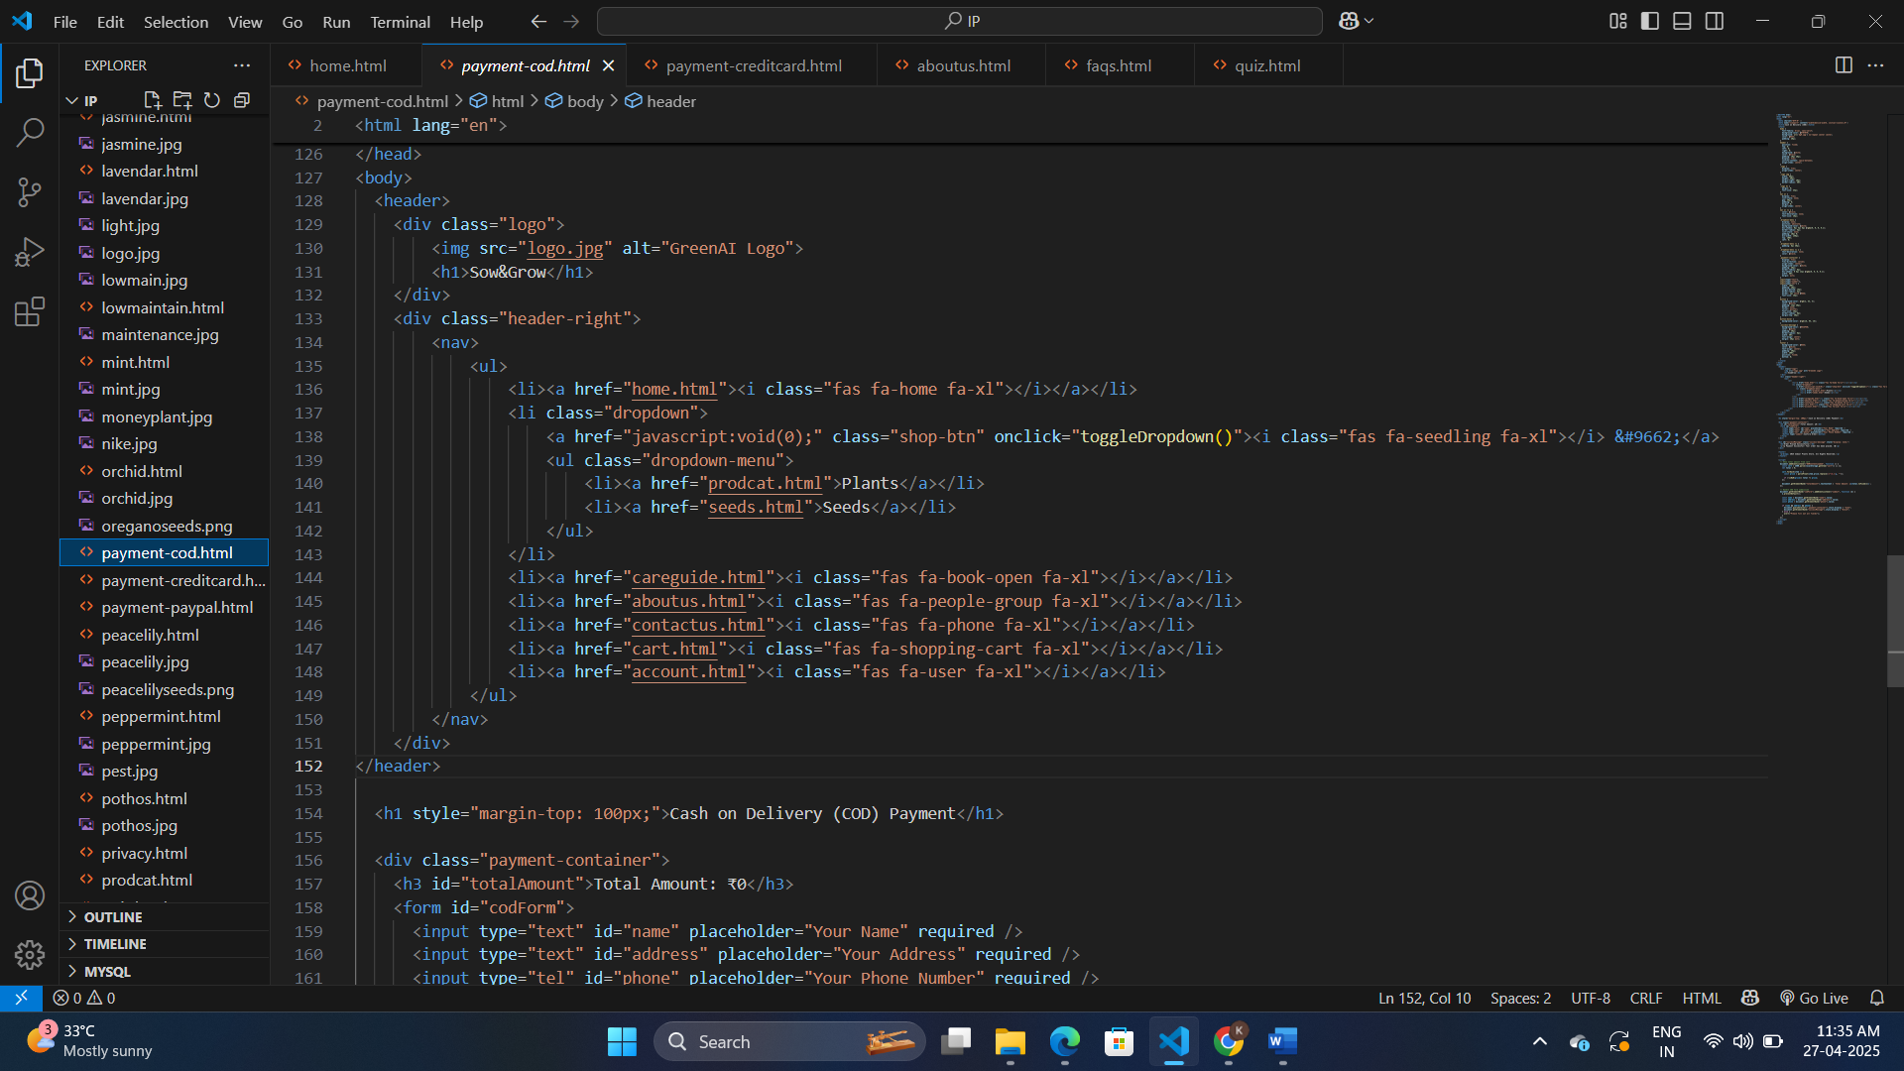

**PRODUCT PAGE:**

